 | Product Specifications Sheet  TRC320  THINSULATE  ACRYLIC HAT | 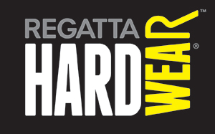

Fabric Information

- Acrylic with Thinsulate lining

Single Size

Quantity per carton
96

Colours
1. Navy 540
2. Black 800
3. Classic Royal 91N
4. Moss 391

Country of Origin- CHINA

Commodity Code- 65059030

COLOUR | PANTONE
1. Navy 540 | 19-3923TCX
2. Black 800 | 19-4008TCX
3. Classic Royal 91N
4. Moss 391 | 19-0506TCX

